Physics
Stage 3 Written Paper Semester One 2010

Question/Answer Booklet

Student Number: In figures

In words

SUGGESTED
Student name: MARKING KEY Teacher name: _______________

Time allowed for this paper
Reading time before commencing work: ten minutes
Working time for paper: three hours

Materials required/recommended for this paper

To be provided by the supervisor
This Question/Answer Booklet
Formulae and Constants Sheet

To be provided by the candidate
Standard items: pens, pencils, eraser, correction fluid, ruler, highlighters
Special items: non-programmable calculators satisfying the conditions set by the Curriculum Council for this course

Important note to candidates
No other items may be taken into the examination room. It is your responsibility to ensure that you do not have any unauthorised notes or other items of a non-personal nature in the examination room. If you have any unauthorised material with you, hand it to the supervisor before reading any further.

Student Marks
Section | Percentage of paper | Maximum mark | Student Raw Mark | Student Scaled mark
Section One:  Short response | 30% | 54 |  | out of 30
Section Two:  Problem-solving | 50% | 90 |  | out of 50
Section Three:  Comprehension | 20% | 36 |  | out of 20
Student Mark |  |  |  | out of 100
Structure of this paper

Section | Number of questions available | Number of questions to be answered | Suggested working time  (minutes) | Marks available | Percentage of exam
Section One:  Short response | 14 | 14 | 50 | 54 | 30
Section Two:  Problem-solving | 7 | 7 | 90 | 90 | 50
Section Three:  Comprehension | 2 | 2 | 40 | 36 | 20
 |  |  |  | 180 | 100

Instructions to candidates

1. The rules for the conduct of Western Australian external examinations are detailed in the Year 12 Information Handbook 2010. Sitting this examination implies that you agree to abide by these rules.

2. Write answers in this Question/Answer Booklet.

3. You must be careful to confine your responses to the specific questions asked and to follow any instructions that are specific to a particular question.

- Working or reasoning should be clearly shown when calculating or estimating answers. Answers should be given to the appropriate number of significant figures. Answers not given to the appropriate number of significant figures may result in marks being deducted.

5. Spare pages are included at the end of this booklet. They can be used for planning your responses and/or as additional space if required to continue an answer.
  - Planning: If you use the spare pages for planning, indicate this clearly at the top of the page.
  - Continuing an answer: If you need to use the space to continue an answer, indicate in the original answer space where the answer is continued, i.e. give the page number. Fill in the number of the question(s) that you are continuing to answer at the top of the page.

NOTE TO MARKERS:
Use of significant figures is assessed in question 22.
Section One: Short response 30% (54 Marks)

This section has 14 questions. Answer all questions. Write your answers in the space provided.

Spare pages are included at the end of this booklet. They can be used for planning your responses and/or as additional space if required to continue an answer.
  - Planning: If you use the spare pages for planning, indicate this clearly at the top of the page.
  - Continuing an answer: If you need to use the space to continue an answer, indicate in the original answer space where the answer is continued, i.e. give the page number. Fill in the number of the question(s) that you are continuing to answer at the top of the page.

Suggested working time for this section is 50 minutes.

Question 1 (4 marks)
You are flying at 2.50 x 10² km h⁻¹ near one of the Earth’s poles in an all-metal plane. The plane, which has wing tips that are 40.0 m apart, is flying horizontally due East where the vertical component of the Earth’s magnetic field is 4.50 x 10⁻⁵ T downwards.

a. Calculate the emf induced in the plane’s wings. (3 marks)

v = 250 km h⁻¹
= 69.44 m s⁻¹ emf = Blv
(1 mark) = 4.5 x 10⁻⁵ x 40 x 69.44 (1 mark)
= 0.0750 V

emf = 0.125 V (1 mark)

b. Are you near the north pole or the south pole? North Pole (1 mark)

Question 2 (3 marks)

Calculate the force of the Earth on a 1.00 x 10³ kg satellite which is travelling at 5.00 x 10³ km above the Earth's surface.

r_{T} = r_{E} + r_{s} 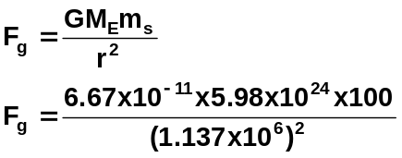 (1 mark)
= 6.37 x 10⁶ + 5.00 x 10⁶
= 1.137 x 10⁷ m F_{g} = 3.09 x 10² N (1 mark)
(1 mark)

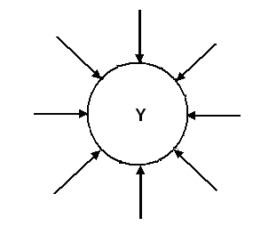
Question 3 (3 marks)

The gravitational field lines are shown for planet Y.
Planet X has the same radius but is less massive then planet Y.

a. If you were to compare the diagrams for planet X and Y, which statement below is correct?

- Planet X would have fewer field lines.
- Planet X would have more field lines.
- Planet X would have the same number of field lines.
- More information is required.
answer: _____A_____ (1 mark)

- Explain your answer. (2 marks)

As there is less mass, there is less gravitational field (1 mark)
at the same distance from the planet’s surface (r constant) (1 mark)

Alternative marking:
Students may prefer a mathematical answer so
g =G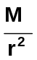; r and G are constant, therefore g ∝ M (1 mark)
so reduce M reduces g (1 mark)

Question 4 (3 marks)
A coffee shop has a sign hanging from a horizontal uniform rod fixed to the wall. The 5.50 kg rod extends from the wall 1.25 m. The sign is hanging at the end of the rod and it has a mass of 15.0 kg. Calculate the moment of force about the point where the rod is fixed to the wall.

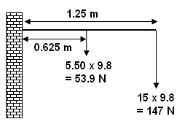
M = Fr⊥
= (53.9 x 0.625) + (147 x 1.25) (2 marks)
= 33.6875 + 183.75
= 217.4375

M = 217 N m (1 mark)

(1 mark if diagram included but no working shown)

Question 5 (4 marks)

Some electric trains use electromagnetic induction to help slow the train. Below is a simplified diagram of this system. It shows an aluminium disk between two electromagnets on an axle which is attached to the wheels of the train. When the engineer needs the train to stop, the switch, S, is closed and a current flows in the coil around the soft iron bar.
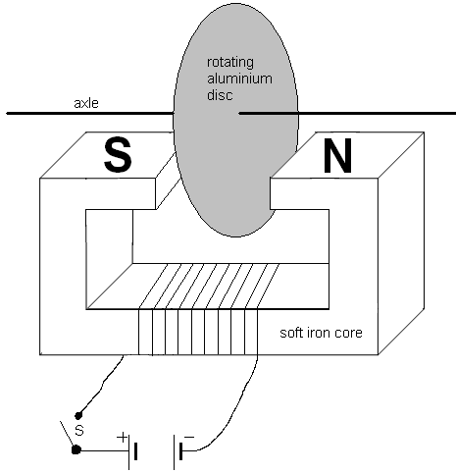

Explain, in terms of electromagnetic induction, why the disc slows down when the switch is closed.

Due to Lenz’s Law. (1 mark)

When switch closed, current runs through the soft iron core forming an electromagnet and a magnetic field. (1 mark)

The disc cuts the magnetic field creating a changing magnetic field which induces Eddy currents in the aluminium disk which in turn creates a magnetic field (1 mark)

This magnetic field opposes the magnetic field from the electromagnetic causing a force from the induced current’s magnetic field which opposes the change and slows disc down. (1 mark)

If students have labelled the north and south ends of the magnet on the diagram and but have little else, you can give a mark for this.

Question 6 (5 marks)

  - An archer fires an arrow at a target at 50.0⁰ to the horizontal. The initial velocity of the arrow is 35.0 m s⁻¹ and the archer hits the bullseye. If the release height was the same height above the ground as the bullseye, calculate how long the arrow was in the air. (3 marks)

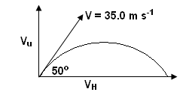
up is positive
V_{u} = V sin φ 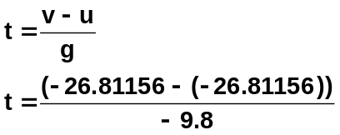
= 35 sin 50
= 26.81156 m s⁻¹
V_{V} = -26.81156 m s⁻¹
g = -9.8 m s⁻²
(1 mark) 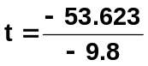 (1 mark)
t = 5.47 s (1 mark)

  - On the graph below, sketch the shape of the path of the arrow without air resistance (label this graph 1) and with air resistance (label this graph 2). (2 marks)

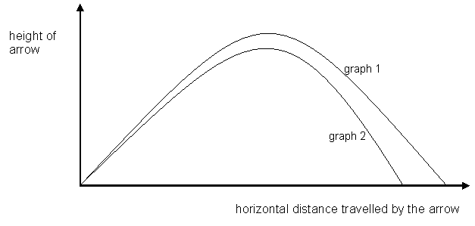

labels on each line – 1 mark
graph 2, not as high and shorter distance to graph 1 – 1 mark

Question 7 (5 marks)

Eric is riding his skateboard down a long hill which has a 15⁰ slope. Halfway down he is travelling at a constant velocity of 3.25 m s⁻¹.

- Sketch a free body diagram showing the forces acting on the skateboarder. (2 marks)
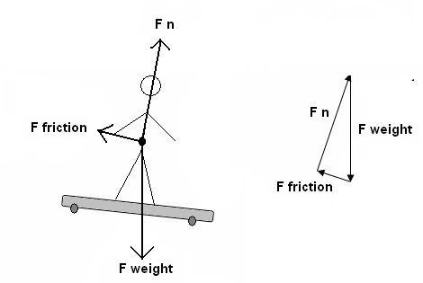(1 mark for arrows )
(1 mark for labels on arrows)

- Based on your diagram and your understanding of equilibrium in physics, state if the skateboarder is in equilibrium and explain your reasoning. (3 marks)

Yes, he is in equilibrium. (1 mark)

As he is travelling with a constant velocity, (1 mark)
all the forces acting upon him are balanced. (1 mark)

Alternative Answer:
Could also discuss in terms of Newton’s First Law as straight line motion and objects tend to remain in motion unless acted on by an unbalanced force (1 mark) and as no unbalanced force, in equilibrium. (1 mark)

Question 8 (3 marks)

A cyclist is maintaining a constant speed around a circular track of radius 75.4 m. The mass of the cyclist and her bicycle is 65.0 kg and the net force on the cyclist is 144 N. Calculate the speed of the cyclist.

F_{c} = 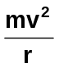 therefore v = 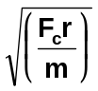 (1 mark)
v = 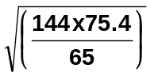 (1 mark)
v = 12.9 m s⁻¹ (1 mark)

Question 9 (4 marks)

A small electrical device runs on a transformer with a primary coil of 5.00 x 10² turns and a secondary coil of 25.0 turns.

- Calculate the output voltage when the transform operates off the 240.0 V supply. (2 marks)

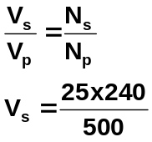

(1 mark)

V_{s} = 12 V (1 mark)

- Calculate the current supplied to the electrical device if the current in the primary coil is 0.400 A. (2 marks)

As energy must be conserved, power must be the same
so input power = output power

V_{p} x I_{p} = V_{s} x I_{s} (1 mark)
240 x 0.400 = 12 x I_{s}
I_{s} = 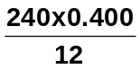
I_{s} = 8.0 A (1 mark)

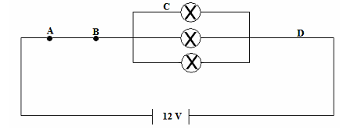
Question 10 (3 marks)

Consider the following circuit. Each ohmic globe in the circuit has a resistance of 150 Ω.

A globe of equal value is now placed between points A and B. What effect would it have on the brightness of the globes in the parallel section? Justify your answer with calculations.

Without R_{A-B}, ,
R = (150⁻¹ + 150⁻¹ + 150⁻¹)⁻¹ R_{T} = 50Ω (1 mark)

with R_{A-B}
R = (50 + 150) R_{T} = 200Ω (1 mark)

As greater resistance with R_{/a-B}, less current so globes get dimmer. (1 mark)

Question 11 (4 marks)

A large marble of 45.0 g is rolling on a flat, frictionless, horizontal surface with a velocity of 3.50 m s⁻¹ north when it is struck and has its velocity changed to 3.50 m s⁻¹ east. If the change took place in 0.150 s, determine the average force exerted on the object.

u = 3.5 m s⁻¹ north 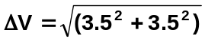
v = 3.5 m s⁻¹ east = 4.95 m s⁻¹ (1 mark)

ΔV = v – u F = 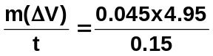 (1 mark)
= 3.5 east – 3.5 north = 1.485
= 3.5 east + 3.5 south
F = 1.49 N E 45⁰ S (1 mark value)
(1 mark direction)
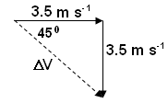

Question 12 (3 marks) Image courtesy dreamstime.com
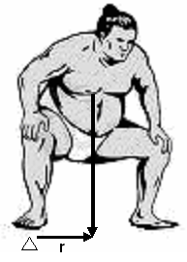
In sumo wrestling, to win the match, one opponent must push the other opponent outside the boundary of the competition ring. At the start of the match, competitors stand facing each other with their feet wide apart and their knees bent as shown in the diagram. Use the diagram to help in your explanation of how this increases the sumo wrestler’s stability.

Feet wide apart increase base over which centre of mass acts, this increases stability (1 mark)

Restoring torque is increased when
radius, r, is increased (1 mark)

Diagram used correctly (1 mark)

Question 13 (5 marks)

Two children decide to make a see-saw by placing a uniform plank over a fallen tree. The plank is 4.00 m long and weighs 1.00 x 10² N. Annie weighs 4.00 x 10² N and Bill weighs 3.00 x 10² N. They move the plank across the tree until they can both sit at either end of the plank and balance the see-saw.

- Determine the position of this balance point? (4 marks)

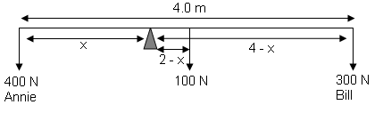

Take moments about pivot

ΣCM = ΣACM
(400 x x) = (100 x [2 – x]) + (300 x [4 – x]) (3 marks – 1 mark for each section correct)
400x = 200 – 100x + 1200 – 300x
400x +300x + 100x = 200 + 1200
800x = 1400
x = 1.75

Balance point is 1.75 m from Annie (1 mark)

- Calculate the force the tree exerts on the see-saw. (1 marks)

F down = 400 + 100 + 300
F down = 800 N
F down = 8.00 x 10² N (1 mark)

Question 14 (5 marks)

In 1993, Javier Sotomayor of Cuba cleared 2.45 m to hold the longest standing record for men’s high jump which was still unbroken in 2009. Javier has a mass of 82.0 kg and his centre of mass is raised 1.45 m above the bar in the jump. Calculate the power expanded by Javier as he cleared the bar. (Ignore the power expended in the run up).

W = Fs = mgh
= 82 x 9.8 x 1.45 (1 mark)
= 1165.22 J (1 mark)

s = ut + 1/2 gt² but u = 0 (from top down) so
t = 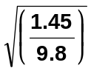 (1 mark)
t = 0.3847 s (1 mark)

P = 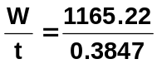
P = 3937.64

P = 3.03 x 10³ W (1 mark)

Section Two: Problem-solving 50% (90 Marks)

This section has seven (7) questions. You must answer all questions. Write your answers in the space provided.

Spare pages are included at the end of this booklet. They can be used for planning your responses and/or as additional space if required to continue an answer.
  - Planning: If you use the spare pages for planning, indicate this clearly at the top of the page.
  - Continuing an answer: If you need to use the space to continue an answer, indicate in the original answer space where the answer is continued, i.e. give the page number. Fill in the number of the question(s) that you are continuing to answer at the top of the page.

Suggested working time for this section is 90 minutes.

Question 15: (12 marks)

Jack, who was standing in front of his house, threw a ball to Alan who was standing on the balcony of their double storey house. Jack was standing 5.00 m horizontally from the house and the ball was 1.65 m above the ground when it left Jack’s hand. The ball was travelling horizontally when Alan caught it 5.50 m above the ground.
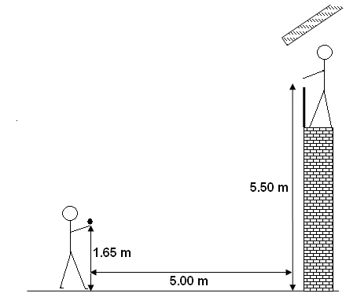

a. Calculate the vertical component of the initial velocity of the ball. (3 marks)

Let up be positive v² = u² + 2 a s
v = 0 m s⁻¹ 0 = u² + [ 2 x (-9.8) x 3.85] (1 mark)
a = -9.8 m s⁻² -u² = -75.46
s = 5.5 – 1.65 m u = 8.68677 m s⁻¹
= 3.85
(1 mark)

The initial vertical velocity is 8.69 m s⁻¹ (1 mark)

b. Calculate the time taken for the ball to reach Alan. (2 marks)

v = 0 m s⁻¹ v = u + a t
a = -9.8 m s⁻² 0 = 8.68677 + (-9.8) t (1 mark)
u = 8.68677 m s⁻¹ t = 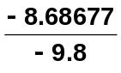
t = 0.8864 s

The time for the ball to reach = 0.886 s (1 mark)

c. Calculate the horizontal component of the initial velocity of the ball. If you could not obtain a value for part (b), use 0.850 s. (2 marks)

Horizontal component = v_{h} = 
= 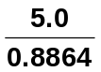 (1 mark)

= 5.64076 m s⁻¹

horizontal component = 5.64 m s⁻¹ (1 mark)
(if use alternative value: 5.88 m s⁻¹)

d. Calculate the angle at which the ball was initially thrown. (2 marks)

tan φ = (5.64076 ÷ 8.68677) (1 mark)
= 38.86267

φ = 38.9º to the vertical OR 51.1º to the horizontal (1 mark)

e. What total energy has Jack given the ball if it has a mass of 45.0 g. (3 marks)

Total energy = E_{p} + horizontal kinetic energy

= mgh + 1/2 mv² (1 mark)
= (0.045 x 9.8 x 3.85) + (0.5 x 0.045 x 5.64076²) (1 mark)
= 1.69785 + 0.7159
= 1.43 J (1 mark)

Question 16: (15 marks)

The diagram below shows two of the many coils found within a typical DC motor. In this motor, each coil is 15.0 cm long and 5.00 cm wide and consists of exactly 300 turns. The coils carries a current of 20.0 A within a magnetic field of 0.800 T.

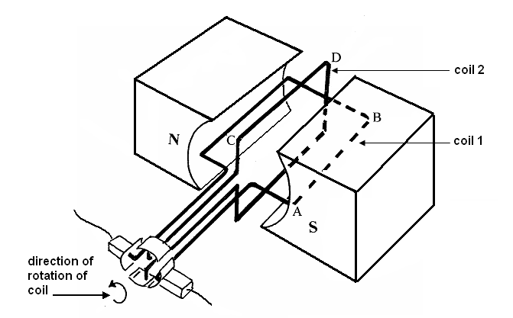
- Is the current direction for coil 1 from A to B or from B to A? (1 mark)

________B to A___________ (1 mark)

- At the instance shown in the diagram, which of the coils, 1 or 2, is experiencing a maximum torque due to the magnetic field to show the direction of motion indicated on the diagram? (1 mark)

________Coil 1 _________________ (1 mark)

- Calculate the force, at this instant, experienced by the coil you selected in part (b) above.
(2 marks)

F = nBI
= 300 x 0.8 x 20.0 x 0.15 (1 mark)
= 720
F = 7.20 x 10² N (1 mark)

- Calculate the total torque, at this instant, experienced by the coil you selected in part (b) above. If you could not calculate a value for part (c), use 7.00 x 10² N. (2 marks)

τ = 2Fr⊥
= 2 x 720 x (0.5 x 0.05) (1 mark)
= 36.0 N m (1 mark)

(alternative answer: 35.0 N m)

- The motor described on the previous page is a very simple motor. More advanced motors can have up to 12 separate coils each with a large number of turns of wire. Describe two advantages that this type of motor would have compared to a simple motor with one coil.
(2 marks)

More coils at different angles means that the coils have a larger average radius and as τ = Fr⊥, this results in more torque. (1 mark)

More coils produces a more constant speed and smoother operation. (1 mark)

- A simple generators and motors are similar in that they contain permanent magnets and rotating coils within the magnets. Explain how a motor is different from a generator.
(2 marks)

The motor is driven by an externally supplied current to produce a torque. (1 mark)

The generator is rotated by an externally supplied torque to create a current.
(1 mark)

Many outback farms use generators to supply electricity to the homestead. Consider the situation below in which a 240.0 V generator delivers 200.0 V to two motors. When operating, the current delivered to motor A is 12.0 A and to motor B is 9.00 A and to lighting in the homestead, 4.00 A.

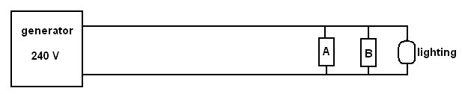

- Calculate how much power the generator produces when both motors and the lights are operating? (3 marks)

P = V x I
P = 240 x (12 + 9 + 4) (2 marks)
= 6 000 W
P = 6.00 x 10³ W OR 6.00 kW (1 mark)

- Determine the effective resistance of the cables? (2 marks)

P = I² x R
1000 = 25² x R (1 mark)
R = 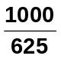
R = 1.60 Ω (1 mark)

This page has been left blank

Question 17: (12 marks)

Two small helicopters are lifting a car from the wharf onto a cargo ship as shown in the diagram below (not to scale). The car has a mass of 9.50 x10² kg and is attached to two cables, T1 and T2, as shown. The first helicopter is attached at an angle of 30.0⁰ to the horizontal and the second at and angle of 40.0⁰ to the horizontal. Each cable has a tension of 2.00 x 10⁴ N.
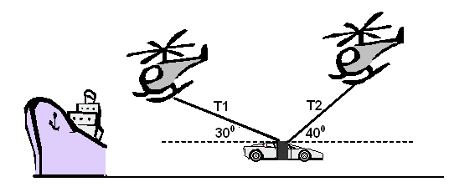

- Calculate the net vertical force acting on the car. (5 marks)
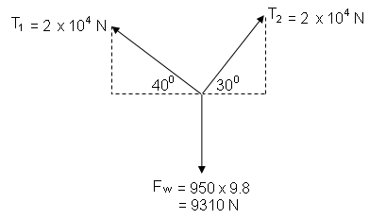

Weight – only vertical force down = 9310 N down

T₁ - vertical = 2.00 x 10⁴ x sin 30 = 10 000 N up (1 mark)

T₂ - vertical = 2 x 10⁴ x sin 40 = 12 856 N up (1 mark)

Vertical = 10 000 + 12 856 - 9310 (1 mark)
= 13 546 N up
= 1.35 x 10⁴ N up (2 marks)

- Calculate the net horizontal force acting on the car. (4 marks)

T1 - horizontal = 2.00 x 10⁴ x cos 30 = 17 320 N left (1 mark)

T2 - horizontal = 2 x 10⁴ x cos 40 = 15 321 N right (1 mark)

Horizontal = 17 320 – 15 321 (1 mark)
= 1 999 N left
= 2.00 x 10³ N left (1 mark)

- What is the resultant force acting on the car? (3 marks)

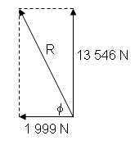
R = 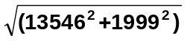
R = 1.37 x 10⁴ N (1 mark)

φ = tan⁻¹ (13 546 ÷ 1 999)
= 81.6⁰ (1 mark)

F_{R} = 1.37 x 10⁴ N to the left (towards ship) at
81.6⁰ to horizontal as shown in diagram. (1 mark)

Question 18: (12 marks)

A uniform diving board has one end firmly fixed by bolts to a concrete block and is supported by a single iron strut as shown in the diagram below. The board has a mass of 65.5 kg and is 4.50 m long. An 85.0 kg diver is standing 0.200 m from the end of the board ready to dive in.
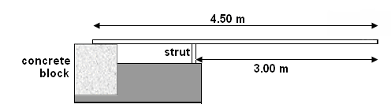

- Draw a labelled diagram showing all the forces acting on the board including the diver.
(2 marks)

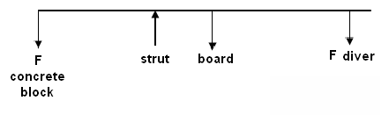
1 mark for arrows
1 mark for labels

- Calculate the force acting on the bolts on the concrete block when the diver is standing 0.200 m from the end. (5 marks)

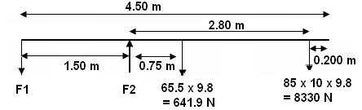

Take moments about F2
ΣCM = ΣACM
(641.9 x 0.75) + (833 x 2.80) = (F1 x 1.50) (3 mark – 1 mark for each section
in brackets)
481.425 + 2332.4 = 1.50F
2813.825 = 1.50F
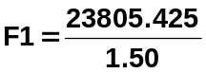 = 1875 N

F1 = 1.88 x 10³ N down
(1 mark) (1 mark)

- Determine the force on the strut. (3 marks)

F up = F down
F2 = 833 + 641.9 + 343 (1 mark)
F2 = 9.31 x 10³ N up
(1 mark) (1 mark)

d. A safety margin built into the attachment at the concrete block would allow for a force 10 times that of the 85.0 kg diver to be standing 0.200 m from the end of the board. Calculate the mass of the concrete block to allow for this safety margin? (2 marks)

F1 = 15870 N
10 times this force = 10 x 15870
= 158700 N (1 mark)

therefore mass of block = 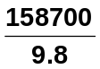

= 162 x 10⁴ kg (1 mark)

Question 19: (10 marks)

- (i) Draw the field around two magnets with opposite poles facing. (2 marks)

1 mark field
1 mark direction

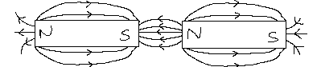

  - Draw the field around a wire carrying a current into the page. (2 marks)

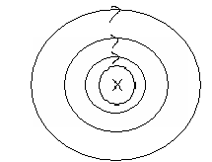
1 mark field
(field lines increased distance apart to
show decreasing field strength)

1 mark direction

  - Draw the field around the combination of the two situations and indicate the direction of the force on the wire. (3 marks)

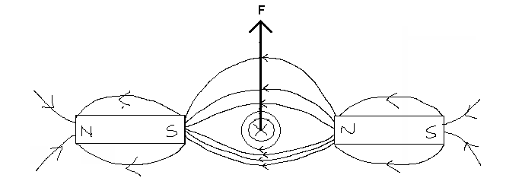

1 mark field
1 mark direction
1 mark for force arrow

- The wire is now suspended between a large horseshoe magnet as shown. Flexible supports hold the wire allowing a current to flow through the wire.
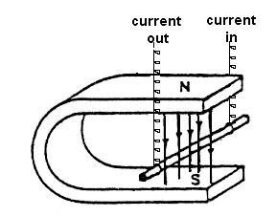

(i) When the current is turned on, the wire will: (1 mark)

A: Move left into the horseshoe magnet.
B: Move right away from the horseshoe magnet.
C: Move upwards towards the north pole of the magnet.
D: Move downwards towards the south pole.
E: Not move.

Answer: ______B_______

  - Explain your answer to (i) above. (2 marks)

Using right hand rule, fingers indicate magnetic field (N to S), thumb current and palm direction of force. (1 mark)

Using this rule, the palm point out of the horseshoe magnet (to the right) so the wire swings outwards (to the right) (1 mark)

Alternative answer:

Students could also use formula e.g.

F = BI with F, B and I at right angles so
using right hand “slap” rule direction is found.

Question 20: (14 marks)

Below is a picture of two people playing “totem tennis”. They hit the ball horizontally and the ball, attached by a strong cord, travels in a radius of 1.70 m. In the game the ball of mass 0.400 kg is travelling horizontally. The ball takes 1.90 s for one complete circle.

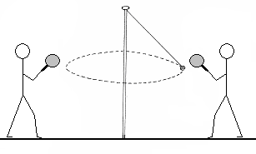

- On the diagram below show all the forces acting on the ball. (2 marks)
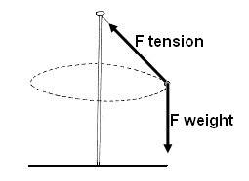
1 mark – weight
1 mark – tension in string
deduct 1 mark if show centripetal force

- Calculate the tension in the cord. (6 marks)

r = 1.7m F_{w} = mg
T = 1.3 s F_{w} = 0.4 x 9.8
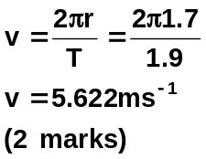 F_{w} = 3.92 N (1 mark)

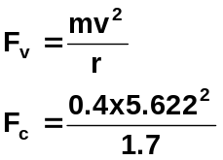 (1 mark)
F_{c} = 7.436 N ( mark)

F_{T} = 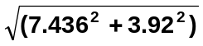
F_{T} = 8.41 N (1 mark)

- Calculate the angle the cord makes with the pole. (2 marks)
φ = tan⁻¹ (7.436 ÷ 3.92) = 62.2⁰ (1 mark)

F = 8.41 N 62.2⁰ to vertical. (1 mark)

- Rearrange the formulas used above to show the relationship between the angle and the velocity and therefore describe what happens to the speed of the ball as the angle decreases. (4 marks)

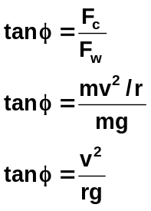

(1 mark)

therefore φ = tan⁻¹ 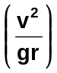

tan⁻¹, g and r are constants so

φ ∝ v² (1 mark)

therefore as angle decreases, v² decreases (1 mark)

so speed of ball will decrease (1 mark)

Question 21: (15 marks)

At university, a student sets up a solenoid as shown below connected to a rheostat, ammeter and power pack. He turns on the power pack and adjusts the rheostat until he has a constant current in the solenoid. He then turns the power pack off.
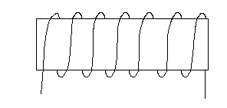
The student then looks at a compass to determine the direction of north when the compass is only experiencing the Earth’s magnetic field. The compass is shown below in Figure one.
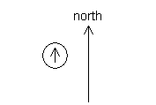

Figure one

He then turns on the power pack and places the compass in various positions as shown in Figure two below.
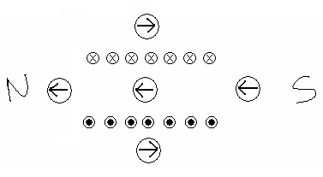

ARROWS:
1 -2 arrows correct – 0 mark
3-4 arrows correct – 1 marks
5 arrows correct – 2 marks

N and S correct – 1 mark

Figure two

  - On Figure two, label the north and south ends of the solenoid then, within each compass shown, sketch the direction of the compass needles when the power pack is on. (3 marks)

  - The magnetic flux passing through each loop in the solenoid is 2.50 x 10⁻⁵ Wb and the solenoid has a radius of 15.0 mm. Calculate the magnetic field strength in the centre of the solenoid. (3 marks)

φ = 2.50 x 10⁻⁵ 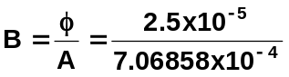 (1 mark)
r = 15 x 10⁻³
A = πr² B = 0.0353678
= 7.06858 x 10⁻⁴ m² B = 3.54 x 10⁻² T (1 mark)
(1 mark)

  - The current is then turned off and the magnetic field drops to zero in 50.0 ms. What is the magnitude of the emf induced in the coil. Show all working. (3 marks)

φ₁ = 2.50 x 10⁻⁵ Wb
φ₂ = 0 Wb
t = 50 x 10⁻³ s
(1 mark)
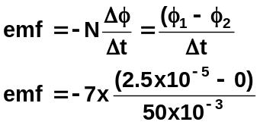 (1 marks)

emf = -3.50 x 10⁻³ V (1 mark)

  - The student then connects the solenoid to an ammeter and moves a magnet towards the coil.
(1 mark)

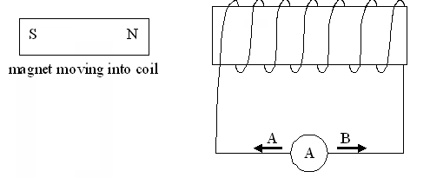

Which way will the current flow?
- Towards A.
- Towards B.
- No current flow.

Answer: ______A_______ (1 mark)

  - Explain your answer to part (d). (3 marks)

As the magnet moves towards the coil it creates a changing magnetic field and an induced current in the coil. (1 mark)

The current in the coil sets up its own magnetic field that opposes the motion of the magnet into the coil – sets up a north pole on left hand side of c. (1 mark)

Using right hand rule for coils, for a north pole on left hand side of coil, current must flow in direction indicated by A. (1 mark)

  - When the magnet is half way in the coil, the student stops to record his results leaving the magnet in the coil. Explain what happens to the current. (2 marks)

Current would stop flowing (1 mark)

No changing magnetic field so no induced current in coil (1 mark)

Section Three: Comprehension 20% (36 Marks)

This section contains two (2) questions. You must answer both questions. Write your answers in the space provided.

Spare pages are included at the end of this booklet. They can be used for planning your responses and/or as additional space if required to continue an answer.
  - Planning: If you use the spare pages for planning, indicate this clearly at the top of the page.
  - Continuing an answer: If you need to use the space to continue an answer, indicate in the original answer space where the answer is continued, i.e. give the page number. Fill in the number of the question(s) that you are continuing to answer at the top of the page.

Suggested working time for this section is 40 minutes.

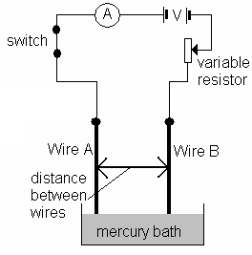
Question 22: (18 marks)

A teacher set up a demonstration to show the force exerted on a current carrying conductor by another current carrying conductor as the current flow is varied in each conductor. The circuit diagram the teacher sets up is shown to the right.

The teacher was able to measure the force wire B exerts on wire A by using a data logger attached to a computer. Resistance in the wires is negligible.

The teacher fixed the distance between the two wires to be 0.0100 m and the lengths of wires A and B to be 0.200 m.

The relationship the teacher was investigating can be found from the following formula:

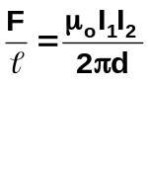 where: F is the force of wire B on wire A (N)
is length of wires (m)
μ_{o} is the permeability of free space
I₁ and I₂ are the currents flowing in the wires (A)
d is the distance between the wires (m)

- List the variables for this experiment. (4 marks)

Independent variable: size of current (1 mark)

Dependent variable: force (1 mark)

Control variables:

thickness of wires
same material for wires
length of wires (two suitable answers – 2 marks)

The results of the demonstration are shown in the table below:

I_{A} | I_{B} | F (x 10⁻⁷) | I_{A} x I_{B}
1.00 | 1.00 | 3.94 | 1.00
2.00 | 2.00 | 16.01 | 4.00
3.00 | 3.00 | 36.10 | 9.00
4.00 | 4.00 | 63.93 | 16.0
5.00 | 5.00 | 99.97 | 25.0
6.00 | 6.00 | 144.03 | 36.0
(1 mark)
- Complete the last column of the table. (1 mark)

- On the graph paper on the next page, plot the graph of force vs (I_{A} x I_{B}). (5 marks)

- State the relationship between the force exerted by wire B on A and the current flowing in the wires. (2 mark)

It is a linear relationship (1 mark)
F being proportional to (I_{A} x I_{B}) (1 mark)

- Calculate the gradient of the line of the graph including units. (3 marks)

Student should indicate on graph where they took the gradient from, if not, deduct 1 mark
as per graph, gradient = 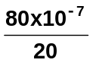 (1 mark)
= 4.0 x 10⁻⁷ N A⁻² NB: should only be 2 significant figures,
(1 mark) (1 mark) if not, deduct 1 mark

- Using your gradient and the formula, calculate the value of μ₀ including units. (3 marks)

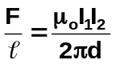 so 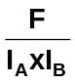 = 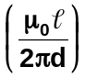 but = gradient

so 4.00 x 10⁻⁷ = (1 mark)
4.00 x 10⁻⁷ = 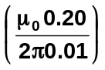
μ_{o} = 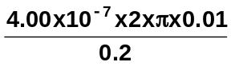 units: 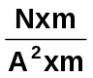

μ_{o} = 1.3 x 10⁻⁷ N A⁻² NB: only 2 significant figures, if not, deduct
(1 mark) (1 mark) 1 mark

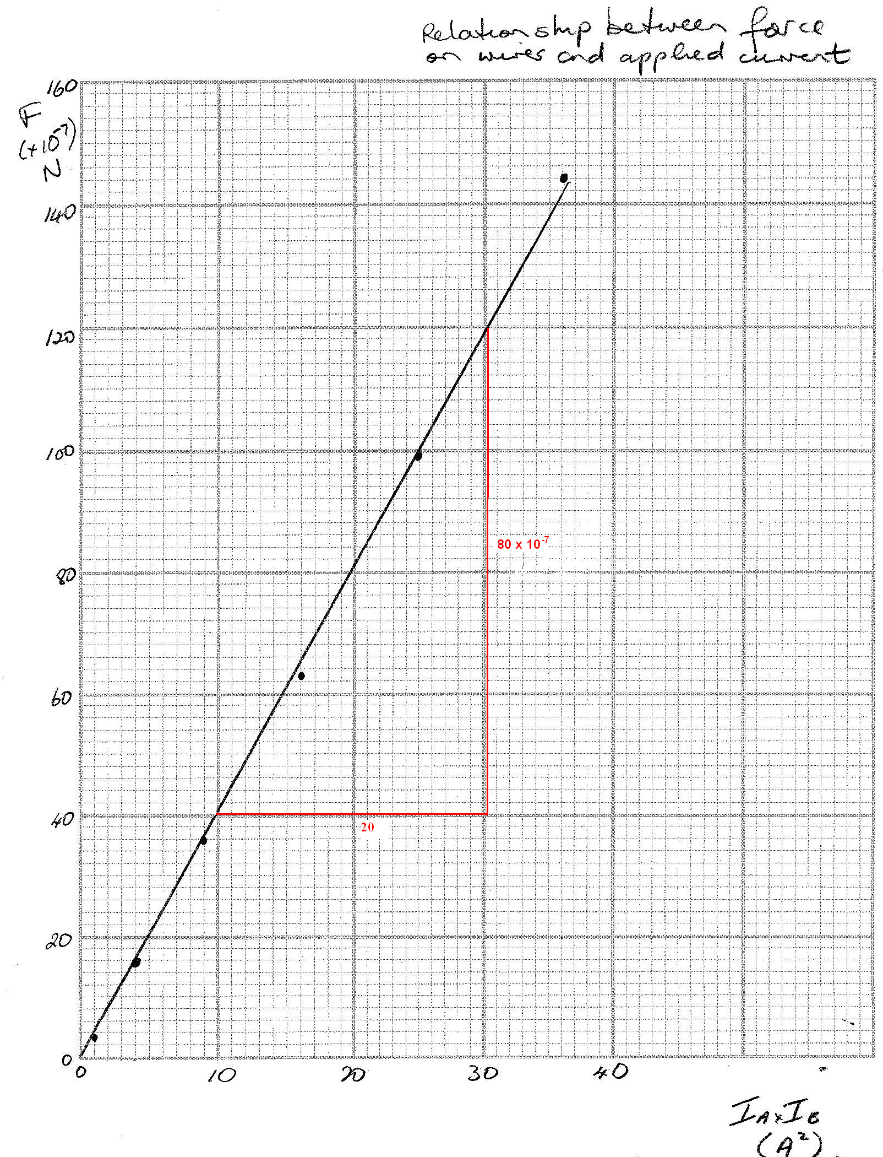

1 mark for each of the following:
- axis correct position
- axis labelled
- point plotted correctly
- line of best fit
- title
Question 23: (18 marks)

An extract from “Dynamics of Satellite Orbits”
Leon Blitzer
University of Arizona
http://www.brookscole.com/physics_d/templates/student_resources/003026961X_serway/optional/satellite.html

Equations 6.3 and 6.4 for the velocity and period of a satellite in a circular orbit about an assumed spherical earth have long been known:

Equation 6.3 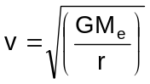 Equation 6.4 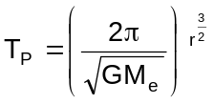

However, the advent of the Space Age had to await the development of rockets with sufficient thrust to propel the payload into orbit. With the launch of Sputnik I on October 4, 1957, artificial earth satellites became a reality, and since then numerous satellites and space probes have been sent into orbit. These manned, as well as unmanned, space explorations have captured the interest and imagination of the entire world. The unique character of the satellite is that it provides a sustained observing platform outside the atmosphere for studying the earth and its environs, as well as outer space. Today, hundreds of satellites and space probes are in orbit, and their applications encompass just about the entire range of science and engineering research.

There is no doubt that the future will see an increasing number of satellites and space probes being used for ever-expanding applications. You should note that Equations 6.3 and 6.4 have application beyond artificial earth satellites, for they are valid for any satellite (moon) moving in a circular orbit about its parent planet, or any planet moving in a circular orbit about the sun. More generally, satellite and planetary orbits are elliptical, the circle being a special case of the ellipse.

The Satellite Orbit Paradox
Clearly, forces are required to overcome the earth's gravitational attraction and to propel a satellite into orbit, with higher orbits requiring greater forces. Consider a satellite moving in a given circular orbit. If the satellite is subjected to some force in the same direction as its motion, it will be propelled into a higher orbit and will travel at a slower speed according to Equation 6.3. Conversely, if the satellite is subjected to some force in a direction opposite to its motion, it will be driven into a lower orbit and will move at a greater speed according to Equation 6.3.

It is known that even at altitudes of 500 km and more above the earth there are sufficient atmospheric particles to create a significant frictional (drag) force on the rapidly moving satellite. Since the frictional force is in a direction opposite to its motion, it will cause the satellite to shift into a lower orbit and move with greater velocity. Hence, we have the so-called "drag paradox"; namely, atmospheric friction causes the orbital velocity to increase. Indeed, all satellites moving within the earth's atmosphere slowly spiral inward at ever-increasing speed until they burn up or impact the earth as can be seen in the diagram below (Figure 1). Moreover, this is also the case for satellites moving in elliptical orbits.
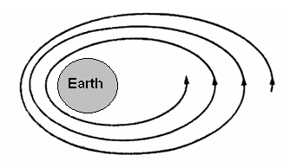
Figure 1. Shrinking of the orbit under atmospheric drag.
Note that the paradox is not limited to drag, for any force acting in the same direction as the motion of the satellite causes the payload to shift into a higher orbit and move with slower speed, while any retarding force actually results in an increase in speed.

Geostationary SYNCOM Satellites
Consider a satellite moving in a circular orbit in the plane of the equator at such a distance that its orbital period is synchronous with the rotational period of the earth, namely one sidereal day. Such a satellite will then be at a fixed geographic longitude, and is referred to as geostationary. Figure 2 below shows three uniformly spaced satellites in synchronous equatorial orbits.

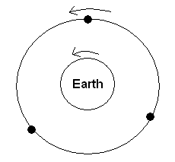
Figure 2

This configuration of three geostationary satellites, when equipped with radio transponders, can provide line-of-sight global communication between any two points on earth. Practically all satellites currently used for communication are in such 24-hour synchronous orbits and hence referred to as SYNCOMS.

- From a context you have studied, besides communication satellites, give one other use for satellites and explain how that use has influenced our daily lives. (2 marks)

Any suitable answer - application 1 mark
influence 1 mark

- A “paradox is a seemingly contradictory statement that may nonetheless be true. Explain why the “Satellite Orbit Paradox” is considered to be a paradox. (2 marks)

Usually, when you think about “drag”, you assume that the speed will decrease. (1 mark)

Drag on a satellites causes it to enter a lower orbit increasing the speed, hence the paradox. (1 mark)

.

- Calculate the velocity needed to keep a satellite in orbit if it is travelling 5.00 x 10³ km above the Earth’s surface . (3 marks)

r_{T} = r_{E} + r_{s} 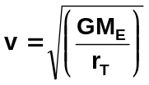
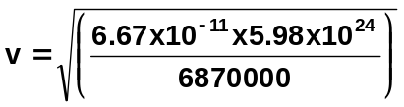 = 6.37 x 10⁶ + 500000
= 6870000 m (1 mark)
(1 mark)
m_{E} = 5.98 x 10²⁴ kg
v = 7.62 x 10³ m s⁻¹ (1 mark)

- Satellites in a 24-hour synchronous orbit must orbit above the equator. Explain why?
(2 marks)

Only when the satellite orbits around the centre of mass can the 24-hour synchronous orbit occur. (1 mark)

Only points above the equator keep in a constant position and rotate around the centre of mass of the Earth. (1 mark)

- AUSSAT was established by the Australian government to provide satellite communication services to Australia. The 2858 kg satellite orbits 36 000 km above the equator. Calculate the acceleration due to gravity on the satellite when it is at this height. (3 marks)

r_{T} = 36000000 + 6.37 x 10⁶
= 42370000 m
(1 mark) g = G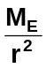
g = 6.67 x 10⁻¹¹ x 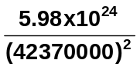 (1 mark)
g = 9.41 x 10⁶
g = 0.222 m s⁻² (1 mark)

- The phrase “line of sight global communications” is used in the last paragraph of the article. In reference to this article, explain the meaning of this phrase. (2 marks)

Always 1 satellite in view (line of sight) (1 mark)
which is always in view (line of sight) of another satellite (1 mark)

- Consider a satellite that has initially been placed in orbit at an altitude of 5.00 x 10² km above the Earth. By how much does the orbit need to be increased so that the satellite is in a 24-hour synchronous orbits? (4 marks)

F_{c} = F_{g} and v = 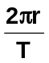(for F_{c})
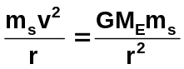 m_{s} cancels (1 mark)
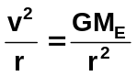
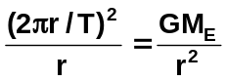

r³ = 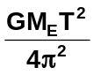 now using T = 24 hours (1 mark)
r³ = 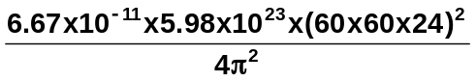
r³ = 7.554 x 10²²
r = 4.23 x 10⁷ m (1 mark)

r_{s} = 6870000 m [from part (c) so no marks]
= 6870 km

6870 – 500 = 6370 km

so need to increase the orbit by 6370 km (1 mark)

End of question 23

______________________________________________________________________________________________________________________________________________________________________________________________________________________________________________________________________________________________________________________________________________________________________________________________________
______________________________________________________________________________________________________________________________________________________________________________________________________________________________________________________________________________________________________________________________________________________________________________________________________
______________________________________________________________________________________________________________________________________________________________________________________________________________________________________________________________________________________________________________________________________________________________________________________________________
______________________________________________________________________________________________________________________________________________________________________________________________________________________________________________________________________________________________________________________________________________________________________________________________________
________________________________________________________________________________________________________________________________________________________________________________________________________________________________________________________________________________________________________________________________________________________________________________________________________________________________________________________________________________________________________________________________________________________________________________________________________________________________________________________________________________________________________________________________________________________________________________________________________________________________________________________________________________________________________________________________________________________________________________________________________________________________________________________________________________________________________________________________________________________________________________________________________________________________________________________________________________________________________________________________________________________________________________________________________________________________________________________________________________________________________________________________________________________________________________________________________________________________________________________________________________________________________________________________________________________________________________________________________________________________________________________________________________________________________________________________________________
____________________________________________________________________________________________________________________________________________________________________________________________________________________________________________________________________________________________________________________________________________________________________________________________________________________________________________________________________________________________________________________________________________________________________________________________________________________________________________________________________________________________________________________________________________________________________________________________________________
________________________________________________________________________________________________________________________________________________________________________________________________________________________________________________________________________________________________________________________
______________________________________________________________________________________________________________________________________________________________________________________________________________________________________________________________________________________________________________________________________________________________________________________________________
______________________________________________________________________________________________________________________________________________________________________________________________________________________________________________________________________________________________________________________________________________________________________________________________________
______________________________________________________________________________________________________________________________________________________________________________________________________________________________________________________________________________________________________________________________________________________________________________________________________
______________________________________________________________________________________________________________________________________________________________________________________________________________________________________________________________________________________________________________________________________________________________________________________________________
______________________________________________________________________________________________________________________________________________________________________________________________________________________________________________________________________________________________________________________________________________________________________________________________________
______________________________________________________________________________
____________________________________________________________________________________________________________________________________________________________
END OF EXAMINATION

